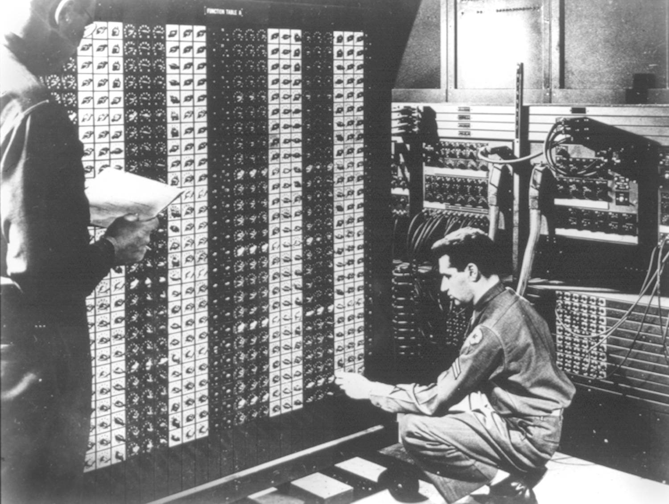 

**Advanced Placement Computer Science**

[**Shenendehowa HS**](http://www.shenet.org/shen-high-school/)[**mr Hanley**](http://hanley.co.nr)

**Unit 6: Arrays/ArrayLists**

**Lesson: ArrayList**

***Last Updated:*** *11/20/2017*

Lesson: Parameter Passing Mechanisms

*Last Updated: 100/11001/1100*

The list interface in Java contains the following methods;(partial list)

The ArrayList is a flexible class for organizing _____________________________

The ArrayList will maintain an array and ___________________________ when needed.

Consider the following class definition

public class Card {

final static int HEARTS=3, DIAMONDS=4, CLUBS=5, SPADES=6;

public int suit, faceValue /*what it would count in blackjack*/, rank /*(who beats who)*/;

public String description; //ie “Queen” or “Jack” or “Two”

public Card(int st, int fv, int r, String desc){

suit = st; faceValue=fv; rank = r; description = desc;

}

public String toString(){

String tempSuit=””;

switch(suit) {

case HEARTS:

tempSuit = “Hearts”;

break;

case SPADES:

tempSuit = “Spades”;

break;

case DIAMONDS:

tempSuit = “Diamonds”;

break;

case CLUBS:

tempSuit = “Clubs”;

}

return description + “ of “ + tempSuit;

}

}

To create an ArrayList of Cards use

To add an element into an ArrayList, use

You try adding two more Cards into the ArrayList

To retrieve an element from an ArrayList(typecasting required here)

You try, retrieving your two Cards out

Changing an element in the ArrayList

You try changing the 3rd card

Adding an element into the ArrayList, Sliding elements at position index and higher to the right

The ArrayList now has 4 elements with the former 2nd and 3rd shifted right

You try, adding a 5th element into the beginning of the ArrayList

Removing an element from the ArrayList, sliding elements left if necessary

Finding the size of the ArrayList

You try, Looping through the cards and displaying them to the screen

Generics

Java SDK 1.5 added some really nifty features.

One badly needed feature was they added generics to the language

To declare an ArrayList of Strings, use

Now you can add and remove Strings with

You Try: Create an ArrayList of Students

Add a Student named Ian Fisher to the ArrayList

Add a second student to the ArrayList, with a name of your own choosing

Add a third student to the ArrayList, with a name of your own choosing

Add a quiz of 95 to the third student

Add a quiz of 99 to the first student

Cycle through the ArrayList and print out the students

FYI, there is also an enumerated type in 1.5

public class Card {

public enum suit { HEARTS, DIAMONDS, CLUBS, SPADES};

//enum stands for enumerate which is a way to define your own types in java!!!!

public suit st;

public int faceValue /*what it would count in blackjack*/, rank /*(who beats who)*/;

public String description; //ie “Queen” or “Jack” or “Two”

public Card(suit s, int fv, int r, String desc)

{

st = s; faceValue=fv; rank = r; Description = desc;

}

public String toString()

{

String tempSuit=””;

switch(suit) {

case HEARTS:

tempSuit = “Hearts”;

break;

case SPADES:

tempSuit = “Spades”;

break;

case DIAMONDS:

tempSuit = “Diamonds”;

break;

case CLUBS:

tempSuit = “Clubs”;

}

return description + “ of “ + tempSuit;

}

}

//Outside of the class, the type is known as Card.suit

//Outside of the class, the individual values are known as Card.suit.HEARTS and Card.suit.